Westmoreland
Emergency Amateur
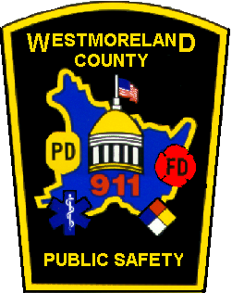
Radio Service

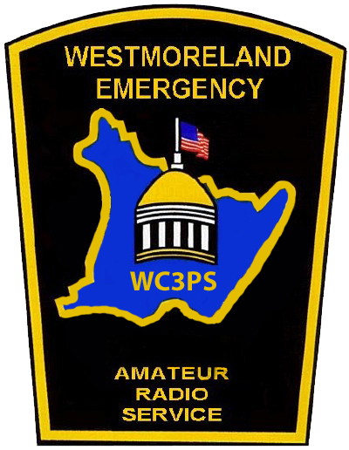
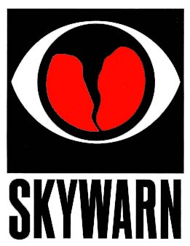
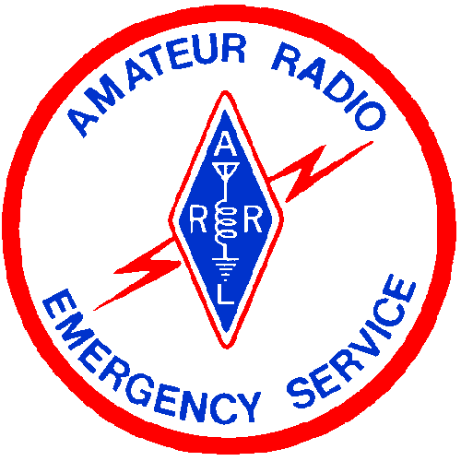

WEARS is the ACS unit for WESTMORELAND County

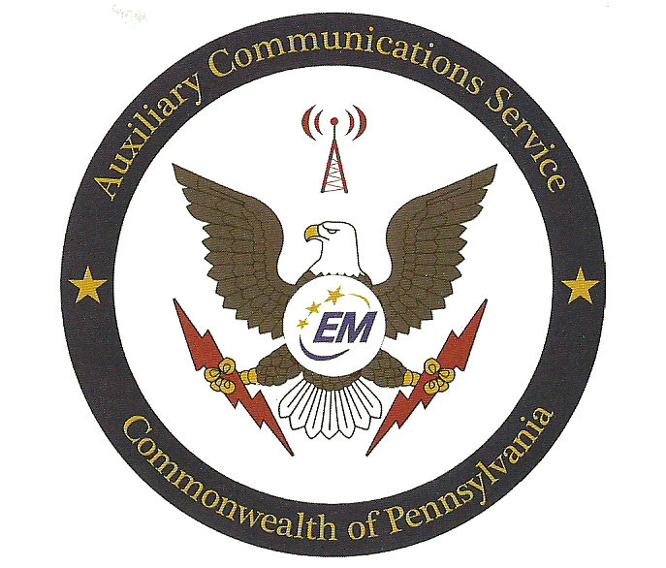

Principles Of Disaster Communications (From the ARRL Public Service Communications Manual)

It is impossible to state exact rules that will cover every situation that arises. The good amateur faced with a disaster situation may, however, benefit greatly from certain rules of thumb. These rules are, or should be, part of the training in the ARES group. They are presented here somewhat at random and should be digested by all amateurs, even those not active in disaster communications preparation.

1. Keep the QRM level down. In a disaster, many of the most crucial stations will be weak in signal strength. It is most essential that all other stations remain silent unless they are called upon. If you're not sure you should transmit, don't. Our amateur bands are very congested. If you want to help, study the situation by listening. Don't transmit unless your are sure you can help by doing so. Don't ever break into a disaster net just to inform the control station you are there if needed.

2. Monitor established disaster frequencies. Many localities and some geographical areas have established disaster frequencies where someone is always (or nearly always) monitoring for possible calls. When you are not otherwise engaged, it is helpful simply to sit and listen on such frequencies, some of which are used for general ragchewing as well as disaster preparedness drilling. On CW, SOS is universally recognized, but has some legal aspects that should be considered where the need is not truly crucial. On voice, one can use "MAYDAY (universal , the phone equivalent of SOS) or, to break into a net or conversation, the word "emergency."

3. Avoid spreading rumors. During and after the disaster situation, especially on the phone bands, you may hear almost anything. Unfortunately, much misinformation is transmitted. Rumors are started by expansion, deletion, amplification or modification of words, exaggeration or interpretation. All addressed transmissions should be officially authenticated as to their source. These transmissions should be repeated word for word, if at all, and only when specifically authorized. In a disaster emergency situation, with everyone's nerves on edge, it is little short of criminal to make a statement on the air without foundation in authenticated fact.

4. Authenticate all messages. Every message which purports to be of an official nature should be written and signed. Whenever possible, amateurs should avoid initiating disaster or emergency traffic themselves. We do the communicating; the agency officials we serve supply the content of the communications.

5. Strive for efficiency. Whatever happens in an emergency, you will find hysteria and some amateurs who are activated by the thought that they must be "sleepless heroes." Instead of operating you own station full time at the expense of you health and efficiency, it is much better to serve a shift at one of the best-located and best-equipped stations, suitable for the work at hand, manned by relief shifts of the best-qualified operators. This reduces interference and secures well-operated stations. (continued on next page)

Principles Of Disaster Communication (From the ARRL Public Service Communications Manual)

6. Select the mode and band to suit the need. It is a characteristic of all amateurs to believe that their favorite mode and band is superior to all others. For certain specific purposes and distances, this may be true. However, the merits of a particular band or mode in a communications emergency should be evaluated impartially with a view to the appropriate use of bands and modes. There is, of course, no alternative to using what happens to be available, but there are ways to optimize available communications. Long experience has developed the following advantages:

CW
1) Less QRM in most amateur bands.
2) Secrecy of communications - contents of communications are much less likely to be intercepted by the general public to start rumors or undue concern.
3) Simpler transmitting equipment
4) Greater accuracy in recording communications.
5) Longer range for a given power.

Phone
1) More practical for portable and mobile work.
2) More widespread availability of operators.
3) Faster communication for tactical or "command" purposes.
4) More readily appreciated and understood by the public.
5) Official-to-official and phone patch communication.

RTTY, AMTOR and Packet
Advantages (1) and (2) of CW, advantage (2) of phone, plus greater speed in record communication than some of the other modes, and-in the case of AMTOR and packet-error detection. In addition, all three digital modes offer the potential for store-and-forward capability from within the disaster site to the "outside world." Finally, packet provides the capability of digi-peating from point A to point Z via numerous automatically controlled middle points. The well-balanced disaster organization will have CW, phone, RTTY, AMTOR, and packet capabilities available in order to utilize all the advantages. Of course one must make the best use of whatever is available, but a great deal of efficiency is lost when there is lack of coordination between the different types of operation in an emergency. Absolute impartiality and a willingness to let performance speak for itself are prime requisites if we are to realize the best possible results.

7. Use all communications channels intelligently. While the prime objective of emergency communications is to save lives and property (anything else is incidental), Amateur Radio is a secondary communications means; normal channels are primary and should be used if available. Emergency channels other than amateur which are available in the absence of amateur channels should be utilized without fear of favoritism in the interest of getting the message through.

- Don’t “broadcast”. Some amateur stations in an emergency situation have a tendency to emulate “broadcast” techniques. While it is true that the general public may be listening, our transmissions are not and should not be made for that purpose. Broadcast stations are well equipped to perform any such service. Our job is to communicate for, not with the general public.

1.0 INTRODUCTION

  - The Westmoreland Emergency Amateur Radio Service (WEARS) is composed of FCC-licensed Amateur Radio Operators who have voluntarily registered their capabilities and equipment for public service communications duty.

  - Under Federal regulations, Amateur Radio public service communications are furnished without compensation of any kind.

  - The WEARS functions under this Emergency Plan under the direction of the Emergency Coordinator (EC), who is appointed by the Amateur Radio Relay League (ARRL) Western Pennsylvania Section Manager (SM) in consultation with the Section Emergency Coordinator (SEC).

1.4 The EC has appointed Assistant Emergency Coordinators (AEC) in the following areas: SKYWARN, Net Operations, Traffic, HF Operations, and Emergency Services.

2.0 PURPOSE

2.1 The purpose of this plan is to provide a written guide containing the necessary information that would be needed by any WEARS member during an emergency.

2.2 The primary function of the WEARS is to furnish communications in the event of a man- made or natural disaster or when regular communications fail or are inadequate.

2.3 To ensure readiness, drills, training and instructions shall be carried out on a regular basis as per Standard Operating Procedure (SOP) 4.0.

2.4 The following agencies could be served during a communications emergency: Westmoreland County Department Of Public Safety (WCDPS), Pennsylvania State Police (PSP), Local Hospitals, National Weather Service (NWS), Emergency Alerting System Stations (EAS), American Red Cross (ARC), Salvation Army (SA), Municipal Police Departments, Fire Departments, and Emergency Medical Services.

3.0 ACTIVATING THE PLAN

3.1 Any member of the WEARS who is aware that a communications emergency exists should monitor the 145.15- repeater or an appropriate frequency as outlined in SOP 4.10.

3.2 An ARES Net will automatically be activated when an EAS alert is broadcast on radio or TV, or the NWS transmits a tone alert for a weather warning or upon the request of any served agency.

3.3 Normally the EC or an AEC will activate an ARES Net. If after a brief period of time, the EC or an AEC is not available, any ARES member may activate the Net.

3.4 If telephone communications are available, the telephone tree will be activated.

4.0 STANDARD OPERATING PROCEDURES

ALL members of the (WEARS) are expected to use proper operating etiquette and follow the standard operating procedures.

4.1 The basis of this system is at the county level. During an emergency, the EC or AEC or a their designated appointee will establish a County ARES Net Control Station (See Appendix 1 for Net Control Procedures) from which amateur operations will be controlled and administered. All ARES operations within the county will operate under this system.

4.2 Next, the EC/AEC will assign each served agency and/or individual area a Field ARES Net Station to communicate to the county ARES net and serve as a control for local operations. The Field ARES Net Stations would utilize 2 or more frequencies or operators, one for communications with County ARES Net and the others for communications with amateurs working for the served agencies.

4.3 For organized handling of formal traffic, the county should use one or more Official Relay Stations (ORS). These stations, a part of the National Traffic System (NTS), are appointed by the Western PA Section Traffic Manager and will operate on the traffic nets as the only stations to handle traffic for the county and interface with the County Net and the Field Net Stations.

4.4 STATION REQUIREMENTS:

4.4.A County ARES Net Stations should, if possible, be an existing station that meets the following requirements. They should be located on high ground, be capable of emergency power operation, and have sufficient space to allow at least two (2) operators to operate simultaneously. The use of an existing station will save set-up time. The stations must be able to operate on 3.983 Mhz / 7.272 Mhz and at least two VHF/UHF frequencies and are encouraged to make use of other bands as needed. The EC will be in direct control of the County ARES net and use it to control all amateur operations within his jurisdiction. Other equipment at these stations should include a complete set of maps of the county and adjoining areas plus emergency supplies deemed necessary. County ARES net stations should be located outside of the disaster area to facilitate access and insure the safety of the operators.

4.4.B Field ARES Net Stations will be set up at the head quarters of each served agency and at local command posts in affected areas. These stations shall be capable of operating on at least two VHF/UHF frequencies. One of these frequencies will be used as a link to the county net and other field nets and the other will be used to communicate with operators assigned to that served agency. Additional frequencies may be added as needed.

4.0 STANDARD OPERATING PROCEDURES (cont.)

4.4 STATION REQUIREMENTS:

4.4.C Official Relay Stations (ORS) should be existing stations that are not in the immediate disaster area. These stations should be adequately staffed and be able to operate on emergency power and must be capable of operating on 80 / 40 meters and VHF/UHF frequencies. They will maintain communications with the County net and other agencies as well as other local amateurs who can handle Health and Welfare Traffic. One of the main purposes or the ORS is to act as direct links to the Section Traffic Nets. During emergencies requiring communications these stations will handle ALL incoming and outgoing formal traffic.

4.4.D Section and District Level Stations should be existing stations where possible. These stations will be operating on all HF/VHF/UHF frequencies in their area. Whenever possible there should be back-up equipment on all bands and modes. These stations should be manned as each situation requires and capable of 24 hour operation for extended periods, if required.

4.5 For all operations within the county, all “Nets” will utilize one frequency for inter-station communications, while using separate frequencies for operations on behalf of served agencies or groups.

4.6 The EC/AEC for the county will assign ALL frequencies used in the county and will notify the DEC/SEC of these assignments.

4.7 In the case of conflicts with adjacent counties, the DEC/SEC will act as frequency coordinator. Simplex VHF and UHF frequencies should be used for these operations whenever possible. This will keep area repeaters available for use by amateurs shadowing officials or providing wide area coverage for an agency requiring the use of autopatches.

4.8 ALL STATIONS WILL MAINTAIN COMPLETE LOGS. All fixed stations operating during an emergency must maintain a complete log of their operation. This log will contain the TIME of each message, the CALL of the contracted station, the MESSAGE CONTENT of the message, and the DATE(s) of operation. A copy of FORMAL TRAFFIC will be kept and become part of the log. Each log sheet will contain the OPERATING CALLSIGN, the location of the station, the call of the operator and be signed by the control operator.

All logs will be kept as part of the ARES records. If an operator requires copies for his own log, copies should be made and the originals retained for the ARES records. (See Appendix 2 for Log Form). (See Appendix 5 for Traffic Forms).

4.0 STANDARD OPERATING PROCEDURES (cont.)

4.9 PERSONNEL NOTIFICATION
The following criteria should be observed for all call-ups of ARES personnel. Please be sure to notify ALL of the proper people as soon as possible. In the event that a person is not available, notify either the alternate of the immediate superior of that person. This is vital to insure the proper operation of Amateur Radio during an Emergency.

Occurrence Notify
Public Service events & local drills Local ARES personnel
Emergency in your county Local ARES personnel, DEC and/or SEC
Emergency that spreads to adjacent county DEC and/or SEC, EC of adjacent county
When you need assistance DEC and/or SEC

4.10 The following frequencies will be utilized in the described manners:

145.150- Primary Net & SKYWARN Repeater PL 131.8
147.180+ Secondary Net Repeater PL 131.8
442.275+ Primary Administrative Repeater PL 131.8
145.530 Primary simplex NBEMS
453.525 Primary ACS (PEMARS)

146.640- North Repeater (Skyview ARC) PL 131.8
146.970- North Backup 1 Repeater (Bell Point)
145.370- North Backup 2 Repeater (Tarentum) PL 131.8
224.300 North 222 Repeater PL 131.8
444.900 North 440 Repeater PL 131.8
147.525 North Tactical 1
446.025 North Tactical 2

147.225+ South Repeater (Bentleyville)
224.580 South 222 Repeater
443.800 South 440 Repeater
147.540 South Tactical 1
446.050 South Tactical 2

147.015+ East Repeater (Mt. Pleasant ARA) PL 123.0
147.555 East Tactical 1
446.075 East Tactical 2

147.120+ West Repeater (Irwin)
146.925- West Backup Repeater
147.570 West Tactical 1
446.100 West Tactical 2

147.180+ Central Repeater (Foothills ARC) PL 131.8
442.275+ Central 440 Repeater
  - Central & Countywide Tactical 1
446.125 Central & Countywide Tactical 2
223.520 Countywide Tactical 3

146.505+(1 Mhz) Sectionwide Repeat
147.420 Sectionwide Simplex
D-STAR Frequency Information

2 Meters (Usually "C" Node): 145.44000MHz -0.600

70 Centimeters (Usually "B" Node): 442.15000MHz +5.000

23 Centimeters Voice (Usually "A" Node): 1286.00000MHz -12.000

23 Centimeters Digital Data 1250.00000MHz

NORTH
Cities
Arnold
Lower Burrell
New Kensington

Boroughs
Avonmore
Delmont
East Vandergrift
Hyde Park
Murrysville
Oklahoma
Vandergrift
West Leechburg

Townships
Allegheny
Bell
Loyalhanna
Salem
Upper Burrell
Washington

SOUTH

Cities

Boroughs
Donegal
Mt. Pleasant
Scottdale

Townships
Cook
Donegal
East Huntingdon
Mt. Pleasant

CENTRAL
Cities
Greensburg

Boroughs
Hunker
New Stanton
South Greensburg
S.W. Greensburg
Youngstown
Youngwood

Townships
Hempfield
Unity

EAST
Cities
Latrobe

Boroughs
Bolivar
Derry
Laurel Mountain
Ligonier
New Alexandria
New Florence
Seward

Townships
Derry
Fairfield
Ligonier
St. Clair

MON VALLEY
Cities
Monessen

Boroughs
Madison
North Belle Vernon
Smithton
Sutersville
West Newton

Townships
Rostraver
Sewickley
South Huntingdon

WEST
Cities
Jeannette

Boroughs
Adamsburg
Arona
Irwin
Manor
North Irwin
Penn
Trafford

Townships

North Huntingdon
Penn

MAP 1 – W.E.A.R.S. ZONE BOUNDARIES

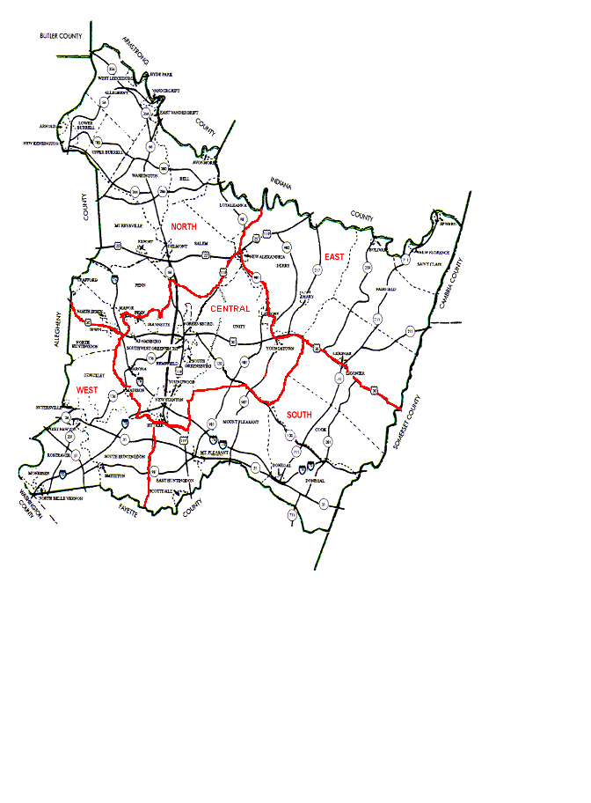

4.0 STANDARD OPERATING PROCEDURES (cont.)

4.11 During a directed net the Net Control Station (NCS) is in charge of all communications. DO NOT attempt to communicate with or otherwise transmit to any station without the express permission of the NCS.

4.12 A Directed Net usually takes one of two forms:
1.) Tactical Communications - those bearing immediate attention such as a tornado or life threatening situation.

2.) Traffic Communications - those that must be structured and entered into the National Traffic System (NTS) for delivery.

4.13 The following Nets will be utilized to their fullest extent:
Pennsylvania Phone Net 3958 Khz @ 1730 local
Western PA Phone and Traffic Net 3983 Khz @ 1800 local
Western PA CW Net 3585 Khz @ 1900 local
Western PA Emergency Net 7272 Khz when necessary
R.A.C.E.S.Net 3990.5 Khz when necessary
Western PA 2M Traffic Net 146.880- @ 2000 local

4.14 Traffic will be passed using the following precedences:

1. Emergency Traffic
2. Priority Traffic
3. Welfare Traffic
4. Routine Traffic

If circumstances do not permit passing of all types of traffic, then the traffic will be dropped in reverse order. If it is humanly possible, stay on the air to pass any Emergency Traffic.

4.15 When calling into a Directed Net there is no need to give the callsign of the Net Control Station (NCS). Simply give your call slowly using phonetics one time. If you have business with the NCS, give your call slowly using phonetics, then follow that with a one or two word description. i.e. November 3 Mike Delta Hotel, Traffic or Whiskey Kilo 3 Mike, Emergency power.

4.16 Once you have checked into the Net, be sure to monitor the operation as continuously as possible. Often time vital information is given during the early stages of the Net.

4.17 If you must leave the Net for any reason, notify the NCS. If possible, provide an estimated time of your return to the Net. Remember to check back into the Net upon your return.

4.18 If you receive an assignment, proceed to that location as quickly and safely as possible. Maintain contact with the NCS while enroute. Remember to consult your Personal Checklist (Appendix 3) as the duration of your assignment may not be known.

4.0 STANDARD OPERATING PROCEDURES (cont.)

4.19 While acting in service to any agency, your primary job is communications. Do not perform any tasks that you are not trained for. The agency is responsible for performing its own tasks.

4.20 While serving other agencies, you will honor their chain of command, and they will honor yours. If unusual circumstances are encountered, contact the NCS, EC or AEC for instructions.

4.21 Listen before you transmit. This is not usually a problem unless you are on FM simplex or HF. Not all stations may be able to hear each other, and you may be disrupting important communications.

4.22 Questions may arise from time to time, don't be afraid to ask for additional details or instructions. It is better to gain additional information than to send supplies or equipment to a wrong location.

4.23 Questioning the procedures used by the NCS is generally inappropriate. Remember, the NCS usually has a better overall view to the situation. If you feel your concern needs to be discussed, contact the EC or AEC.

4.24 PROSIGNS AND PROWORDS can help speed communications but only if they are understood by all operators. Following are some examples:

"OVER" is used to indicate the end of a transmission and that a reply from the receiving station is expected.

"OUT" Indicates the end of transmission and that no reply is expected from the receiving station.

"CLEAR" indicates that the station is leaving the air at the end of this transmission.

"ROGER" means the message has been received and understood in its entirety.
It does not mean "yes" or signify agreement.

"AFFIRMATIVE" or short words for "yes" and "no". They are distinctive in
"NEGATIVE" their sound, and helpful during marginal conditions.

"DIRECT" " Are you direct ?" or did you copy the message directly from the other station. This may save repeating a message. (See Appendix 7 for additional prosigns and prowords)

4.25 If a Sub-Net is to be established, the NCS will assign a Sub-Net Control Station (SNCS). All procedures outlined in this Standard Operating Procedure (SOP) also apply to the Sub-Net.

4.26 Whenever possible, Welfare Traffic should be passed using Disaster Welfare Message Form cd-244 (Appendix 4) utilizing book traffic. All other traffic should be in standard Amateur Radio Relay League (ARRL) form and using numbered radiograms to expedite message delivery. See (Appendix 5) for ARRL precedences and numbered radiograms.

4.0 STANDARD OPERATING PROCEDURES (cont.)

4.27 When passing traffic, send the message only as fast as the receiving station can copy. If Frequency Modulation (FM) or Single Side Band (SSB) is used, talk only at the speed that someone will be able to write. If Continuous Wave (CW) is used, make sure the receiving station can copy that speed. If using Radio Teletype (RTTY), confirm the distant station is set at the same speed/shift.

4.28 DO NOT secure a Net until all traffic has been passed or the situation at hand is under control. If for some reason the Net must be secured, only do so when all resources (time, equipment, manpower, or battery power) have been exhausted.

4.29 DISTRICT LEVEL-The next level to the system is the District. The DEC of each district will maintain operations on the District ARES net frequency (VHF/UHF) or on HF (3.983 Mhz / 7.272 Mhz) during all emergencies requiring communications within the district. The DEC or SEC will be in contact with the County Net and also with the SEC and SM at the section level. All tactical intercounty and interdistrict frequencies will be assigned by the DEC/SEC. All NTS frequencies will be assigned by the NTS Net Manager or the WPA Section Traffic Manager (STM).

If help is needed from outside the county, the EC will contact his DEC/SEC giving a complete list of the number of operators required, how they should be equipped, where to sent them and how long they will be needed. The DEC/SEC will then decide from where to get the help and will contact EC’s/AEC’s in those areas to get the required personal and route them directly to their operating assignments. The DEC/SEC will oversee intradistrict communications and aid the EC where needed.

4.30 SECTION LEVEL-At the section level, the SEC and SM will oversee operations section-wide and coordinate the Districts. All intra-section and inter-section frequencies will be assigned by the SEC or SM. Interaction from Section to Section will be at the Section level unless it is designated by the SEC or SM to the District or County level. All Section communications for the SM, SEC, or DEC should be taken to 3.983 Mhz / 7.272 Mhz or routed via their instructions.

5.0 SKYWARN OPERATIONS

5.1 Purpose: To provide the National Weather Service (NWS) with information relating to severe weather conditions. These conditions may include thunderstorms, hail, high winds, tornadoes, and flooding. The early observation of these conditions by SKYWARN trained amateur radio operators will result in increased protection for the populace of Westmoreland County.

5.2 The assigned Net Control Station (NCS) will refer to Appendix 6 for the form to use to initiate and continue a SKYWARN operation.

STANDBY When a Severe Thunderstorm Watch has been issued, but no weather activity is occurring in the area. Note the expiration time of the watch.

A net control station will then be established and take and log check-ins. Now is the best time to establish where potential observers are located for the upcoming event, not when the severe weather is hitting. The NCS will take the following actions:

1. Listen to the 147.09- repeater to determine if the Weather Net is in progress. The NCS may check in to the Weather Net and advise that the W.E.A.R.S.. SKYWARN Net is in progress, that timely updates will be given, and advise that you will be monitoring on 145.150-. When it is possible, the NCS should assign a station to monitor the Weather Net throughout to obtain updated weather bulletins.

2. The NCS should return to the 145.15- repeater and request check-ins. Updated weather bulletins should also be broadcast. (See Appendix 6 for Net operation announcements.)

The net control station will also relay watch information frequently. Normal use of the repeater will continue, however, please leave a pause between transmissions should net control need to break in to take the net to a higher level.

As the storms approach your area, the net may need to be fully activated. There are three levels of full activation:

5.4 CONDITION GREEN Used during ALL Tornado Watches and during Severe Thunderstorm Watches when active weather is occurring. Nets for Flood/Flash Flood Watches are normally not required. There may be exceptions when the NWS would request additional spotter reports, ex. remnants of a tropical storm moving through the area. The first priority, during condition green, would be taking and relaying weather reports to the NWS. Second would be check-ins. The Net Control Station takes control of frequency and gives frequent updates on net status and weather watches. Prepare for further upgrade as storms approach or if severe weather reports begin coming in.

5.5 CONDITION YELLOW If a SEVERE THUNDERSTORM WARNING and/or FLASH FLOOD WARNING has been issued for our county. Priority must be given to collecting and relaying weather reports, No check-ins or checkouts at this time. Net Control will announce warning information frequently. Only reports meeting the criteria mentioned earlier should be requested. "It's not raining here" reports are not needed, unless requested.

5.0 SKYWARN OPERATIONS (cont.)

5.6 CONDITION RED When used: If a TORNADO WARNING has been issued for your county. Net Control Station takes total control of frequency. Strict Net discipline will be enforced by the NCS during this time. Only stations with Emergency or Priority traffic should give reports. Net Control requests tornado, funnel cloud and wall cloud reports. If there are no tornadic reports, Net Control requests reports meeting the above criteria. Stations without one of the above reports should maintain radio silence. Net control will relay Tornado Warning information frequently. Condition RED events are rare. However, real emergency organization in these instances is what will make the NWS, trained spotters and all licensed amateurs involved with ARES/SKYWARN fulfill their missions and shine.

Special note: The NWS in Coraopolis is equipped with 2-meter gear and both directional and omnidirectional antennas. There are currently amateur radio operators who are employees of the NWS, and members of various Pittsburgh area amateur radio organizations who will establish the Weather Net at the NWS Office.

6.0 WINTER STORM OPERATIONS

6.1 Purpose: To provide governmental and private relief agencies with supplemental communications. These communications will compliment the existing communications systems, provide interoperability between agencies or become the communications system to the extent permitted by the Amateur Radio Emergency Service.

6.2 Winter Storm Status When advised of the need for supplemental communications during a winter storm emergency, the Emergency Coordinator (EC) or Assistant Emergency Coordinator (AEC) will request a Winter Storm Net be established. The Winter Storm Net will be activated when severe winter conditions are present or imminent in Westmoreland County. Severe winter conditions may include snow squalls, poor visibility, icy road conditions, frigid temperatures, ice storms, etc. In the initial stages the Net will be mostly informational. As weather conditions deteriorate or a request for supplemental communications is made it will become a Directed Net. The following items should be addressed by the Net Control Station (NCS):

1.) The EC or an AEC will contact the served agency to determine their communications needs.

2.) Establish Net operations on the 145.15- repeater and requests check-ins. Relay any information that may be pertinent concerning current and expected weather conditions.

3.) Assign a station to contact the Westmoreland County Department Of Public Safety (WCDPS) and make Westmoreland Emergency Amateur Radio Service (WEARS) communications available to them.

4.) Assign stations to monitor the operations of other emergency services, PennDot, local utilities, etc. Monitoring these services will provide additional and pertinent information regarding road closings, power outages.

5.) When possible, assign a station to each vehicle in use by any requesting agency.

6.) If the American Red Cross requests assistance, a WEARS Operator should be assigned to each shelter that is open. If it is possible, assign a second WEARS Operator to the shelter to handle the Disaster Welfare Traffic.

7.) Assign a HF/VHF liaison station to the National Traffic System (NTS).

The preceding are guidelines and do not have to be completed in the order that is listed.

6.3 WEARS personnel are reminded to check Appendix 3 - Personal Checklist before reporting to their assignments. Remember, you don't know how long you may have to stay at your assigned post. !! BE PREPARED !!

7.0 HAZARDOUS MATERIALS INCIDENTS

7.1 Purpose: Westmoreland Emergency Amateur Radio Service (WEARS) operators serve several useful functions in support of the Westmoreland County Hazardous Materials Team 800. Supplying additional communications, assisting in evacuations, and relaying information to and from evacuation centers. WEARS operators may also serve to relay reports from remote observers who are monitoring environmental conditions.

7.2 HazMat Net: In the event that ARES communications are requested for a HazMat incident, a Net will be established by the Net Control Station (NCS) designated by the Emergency Coordinator (EC) or an (AEC).

7.3 The EC or an AEC should act as the contact person to the Hazmat Team. If the EC or an AEC is not available, a WEARS operator should be assigned to the Hazmat Team. All communications to the Hazmat Incident Command Post will be handled through this operator.

7.4 If evacuations become necessary, the NCS should assign operators to each agency involved as well as each evacuation center that is opened.

7.5 Should the Net become congested with traffic, the NCS should consider opening a Sub- Net on the zone repeater or zone simplex frequency.

7.6 The national emergency number for CHEMTREK, the Chemical Transportation Emergency Center in Washington, DC is 1-800-424-9300. If it is necessary for the Hazmat Team to use the autopatch to access this number, the NCS will allow this transmission precedence over all others.

7.7 A reminder that hazardous materials incidents can be a dangerous assignment. While working with the trained professionals who are handling the incident, you are their responsibility, and are to obey any instructions that may be given to you.

8.0 SMALL SCALE DISASTER OPERATIONS

8.1 Definition: A small scale disaster can be man-made or natural in cause and affects no more than 25 homes or 100 persons. An area of 2 square miles or less in size is involved and the duration is less than 24 hours.

8.2 Purpose: During a small scale disaster, Westmoreland Emergency Amateur Radio Service (WEARS) members will provide communications for interoperability, to governmental and private relief agencies engaged in assisting disaster victims. These agencies are not limited to the Westmoreland County Department Of Public Safety; Federal, State, and Municipal Law Enforcement Agencies; Fire and Rescue; Hospitals; American Red Cross; Salvation Army; and Utility Companies.

8.3 Once advised of the small scale disaster, the Emergency Coordinator (EC) or an Assistant Emergency Coordinator (AEC) will request a Net be established and assign a Net Control Station (NCS).

8.4 The Standard Operating Procedure (SOP) (Section 4.0 of this plan) will be complied with. The NCS will monitor operations, and any station not complying will be asked to stop operations and leave the Net and the frequency.

8.5 Additional Sub-Nets may be established as traffic loads increase. These may be set up through zone repeaters or on zone simplex frequencies for local coverage. If these Sub-Nets are established, the Sub-Net Control Station (SNCS) will be required to provide a timely status to the NCS on the main Net.

  - When possible the NCS should attempt to coordinate similar operations to similar frequencies. i.e. Federal, State, and Municipal Law Enforcement Agencies being able to operate on one channel.

  - A liaison with the National Traffic System (NTS) should maintained. This will assure communications into and out of the immediate area.

8.8 Operators should attempt to make an extra effort to write down messages. They needn't be in the radiogram form, but should have correct spelling of names, addresses, equipment on lists, etc.

8.9 Operators are reminded that it is permissible for personnel affiliated with the served agency to speak directly over your radio. The only requirement is that you control the equipment.

9.0 LARGE DISASTER OPERATIONS

9.1 Definition: A large disaster can be man-made or natural in cause and affects more than 25 homes or 100 persons. An area of 2 square miles or greater in size is involved and the duration is more than 24 hours.

9.2 Purpose: As with small disaster operations, WEARS members will provide communications for interoperability, to governmental and relief agencies involved in assisting disaster victims or attempting to return the community to normal. These agencies are not limited to the Westmoreland County Department Of Public Safety; Federal, State, and Municipal Law Enforcement agencies; Fire and Rescue organizations; Hospitals; American Red Cross; Salvation Army; Utility companies.

9.3 Small/Large Disaster Operations: Initially what was assumed to be a small disaster may reach the magnitude of a large disaster. At such a time it becomes apparent that a small disaster will exceed the 24 hour limit, the Net Control Station (NCS) will advise all WEARS members that a Large Disaster operation is in effect. The key component is the duration. The point at which it is apparent the disaster will reach the 24 hour mark, will make it necessary to preserve our resources. This is the point at which shifts will be established to rest operators, allow them to replenish supplies i.e. recharge battery systems, obtain additional rigs and equipment, get food supplies, and most importantly, get some rest.

9.4 Net Status: During Large Disaster operations, the 145.15/144.55 repeater will be in a Net mode and only Emergency or Priority traffic will be handled. As Emergency and Priority traffic begin to taper, it will be the at the NCS's discretion to allow Welfare and Routine traffic to pass. This is where the Sub-Nets play an important role, to handle the less urgent traffic.

9.5 With the assistance of the Emergency Coordinator (EC) or an Assistant Emergency Coordinator (AEC), the NCS will establish a schedule for relief operators for each served agency and assure the communications networks are maintained by WEARS operators.

9.6 During the extended duration of Large Disaster operations, traffic communications will take on an increasing importance. Health and Welfare traffic that needs to go out of the Western Pennsylvania Section will increase. Traffic to Harrisburg, Pittsburgh and governmental centers will be vital to receiving important supplies, equipment, and specialized personnel to assist in relief operations. It is suggested that all traffic be handled through a central messaging station, preferably with RTTY or Packet capabilities.

9.7 The Large Disaster Net operations will be terminated only upon request of the EC, an AEC or one of their liaisons. Even though a formal net has been terminated, it is still advisable to monitor the repeater closely for any station who may have an emergency arise during relief operations. The magnitude of the emergency will determine whether an appropriate net should be established.

10 DATA MODES

10.1 New data modes including but not limited to are narrow band emergency messaging system (NBEMS), D-RATS on the D-star system, Winlink, Echolink.

10.2 Other technology for the new smartphones that may be uses are but not limited to TICKL, Skype.

10.3 NBEMS can be used on a repeater or simplex (see frequency list for standards) .

10.4 D-rats can only be used on the d-star system.

10.5 Winlink is used for Radio Email. (not in use as of yet)

10.6 Echolink is used for internet linking of radios (145.150 has echolink).

APPENDIX 1 - NET CONTROL PROCEDURES FOR A WEARS NET

The Emergency Coordinator (EC) or an Assistant Emergency Coordinator (AEC) will initiate a WEARS Net in the event of a severe weather alert, local disaster or at the request of any governmental or relief agency.

- The EC or an AEC will designate a Net Control Station (NCS) to establish a WEARS Net. If the EC or AEC is not immediately available, they may designate any WEARS member as an Acting EC.

2) The NCS will issue an alert on the Zone Repeaters by reading the following:

"This is (call) EC - AEC - Acting EC Net Control Station for the Westmoreland County A.R.E.S. A (type of net) has been requested by (requesting agency). All stations are requested to switch to 145.15- and monitor that frequency at this time. This is (call) clear."

3) Read the following on the 145.15- repeater:

"This is (call) EC - AEC - Acting EC Net Control Station for Westmoreland County A.R.E.S. A Directed Net is now established at (24 hour time) local time. All communications will be carried out at the direction of the Net Control Station. Only A.R.E.S. members or stations with emergency traffic should break into this net. The purpose of this net (briefly explain the current situation and needs).

4) During the net, a copy of all stations that participated should be kept on the standard A.R.E.S. Net Form along with other pertinent data. This report will be forwarded to the EC after the situation has been resolved.

5) To secure the Net, read the following:

"This is (call) Net Control Station for Westmoreland County A.R.E.S. I wish to thank all stations who participated in the Net. Your help has been greatly appreciated. All stations are secure and this Net is now secure at (24 hour time) local time. The repeater is returned to normal amateur use. This is (call) clear."

Appendix 2 - W.E.A.R.S.. - Net Log Form NCS (call)_________________ Date:____/____/____

Time | From | E  P | A  A | Agency | Comments
EP - Emergency Power AA - Available for assignment

APPENDIX 3 - PERSONAL CHECKLIST

The following are recommendations of equipment, supplies, and personal items that WEARS members should consider having readily accessible for use during an emergency or public service activity.

___ ARES Identification card
___ Alternate form of identification i.e. Drivers license, Passport, Photo I.D.
___ F.C.C. Amateur Radio Operator License

Radio Gear Personal Gear - 72 hour duration

___ Rig or rigs ___ Foul-weather gear
___ Microphone ___ 3-day supply of drinking water
___ Headphones ___ 3-day supply of food in cooler
___ Power supply ___ Mess kit with cleaning supplies
___ Extra batteries ___ First Aid Kit
___ Antennas with mounts ___ Sleeping bag
___ Spare fuses ___ Personal hygiene items
___ Patch cords & adapters ___ Mechanical alarm clock
___ SWR meter ___ Flashlight or lantern with batteries
___ Extra coax ___ Candles with holders
___ Waterproof matches
Writing Gear ___ All items listed on the short duration
personal gear checklist
___ Pens, pencils, and erasers
___ Clipboard Tool Box - 72 hour duration
___ Message forms
___ Log book ___ Screwdrivers
___ Note paper ___ Pliers
___ Socket wrenches
Personal Gear - Short Duration ___ Electrical tape
___ 12 / 120 volt soldering iron
___ Snacks ___ Solder
___ Drinking water ___ Volt-Ohm meter
___ Liquid refreshments ___ Misc. RF and Audio connectors
___ Candy ___ Misc. electronic components
___ Personal medications
___ Throat lozenges Miscellaneous Items - 72 hour duration
___ Aspirin
___ Spare prescription eyewear ___ Hammer
___ Hatchet / Ax
___ Clean, dry spare clothing to last ___ Saw
the length of your assignment ___ Shovel
___ Siphon
___ Jumper cables
___ Nylon rope - at least 50 ft.

FSD-218 | Relief Emergency · Routine Messages  Recommended Precedences

Appendix 5 – ARRL Radiograms

Every formal radiogram message originated and handled should contain the following component parts in the order given.

I. Preamble

a. Number (begin with 1 each month or year)
b. Precedence (R, W, P or EMERGENCY)
c. Handling Instructions (optional, see text)
d. Station of Origin (first amateur handler)
e. Check (number of words/groups in text only)
f. Place of Origin (not necessarily location of station of origin.)
g. Time Filed (optional with originating station)
h. Date (must agree with date of time filed)

II. Address

(as complete as possible, include zip code and telephone number)

III. Text

(limit to 25 words or less, if possible)

IV. Signature

CW: The prosign separates the parts of the address. separates the address from the text and the text from the signature. marks end of message; this is followed by B if there is another message to follow, by N if this is the only or last message. It is customary to copy the preamble, parts of the address, text and signature on separate lines.
RTTY: Same as CW procedure above, except (1) use extra space between parts of address, instead of ; (2) omit cw procedure sign to separate text from address and signature, using line spaces instead; (3) add a CFM line under the signature, consisting of all names, numerals and unusual works in the message in the order transmitted.
PACKET/AMTOR BBS: Same format as shown in the cw message example above, except that the and prosigns may be omitted. Most amtor and packet BBS software in use today allows formal message traffic to be sent with the “ST” command. Always avoid the use of spectrum-wasting multiple line feeds and indentations.
PHONE: Use prowords instead of prosigns, but it is not necessary to name each part of the message as you send it. For example, the above message would be sent on phone as follows: “Number one routine HX Golf W1AW eight Newington Connecticut one eight three zero zulu july one Donald Smith Figures one six four East Sixth Avenue North River City Missouri zero zero seven eight nine Telephone seven three three four nine six eight Break Happy birthday X-ray see you soon X-ray love Break Diana End of Message Over. “End of Message” is followed by “More” if there is another message to follow, “No More” if it is the only or last message. Speak clearly using VOX (or pause frequently on push-to-talk) so that the receiving station can get fills. Spell phonetically all difficult or unusual words--do not spell out common words. Do not use cw abbreviations or Q-signals in phone traffic handling.

Precedences

The precedence will follow the message number. For example, on cw 207R or 207 EMERGENCY. On phone, “Two Zero Seven, Routine (or Emergency).”
EMERGENCY--Any message having life and death urgency to any person or group of persons, which is transmitted by Amateur Radio in the absence of regular commercial facilities. This includes official messages of welfare agencies during emergencies requesting supplies, materials or instructions vital to relief of stricken populace in emergency areas. During normal times, it will be very rare. On cw, RTTY and other digital modes this designation will always be spelled out. When in doubt, do not use it.
PRIORITY--Important messages having a specific time limit. Official messages not covered in the Emergency category. Press dispatches and other emergency-related traffic not of the utmost urgency. Notifications of death or injury in a disaster area, personal or official. Use the abbreviation P on cw.
WELFARE--A message that is either a) an inquiry as to the health and welfare of an individual in the disaster area b) an advisory or reply from the disaster area that indicates all is well should carry this precedence, which is abbreviated W on cw. These messages are handled after Emergency and Priority traffic but before Routine.
ROUTINE--Most traffic normal times will bear this designation. In disaster situations, traffic labeled Routine (R on cw) should be handled last, or not at all when circuits are busy with Emergency, Priority or Welfare traffic.

Handling Instructions (optional)

HXA--(Followed by number) Collect landline delivery authorized by addressee within....miles. (If no number, authorization is unlimited.)
HXB--(Followed by number) Cancel message if not delivered within....hours of filing time; service originating station.
HXC--Report date and time of delivery (TOD) to originating station.
HXD--Report to originating station the identity of station from which received, plus date and time. Report identity of station to which relayed, plus date and time, or if delivered report date, time and method of delivery.
HXE--Delivering station get reply from addresses, originate message back.
HXF--(Followed by number) Hold delivery until....(date).
HXG--Delivery by mail or landline toll call not required. If toll or other expense involved, cancel message and service originating station.

For further information on traffic handling, consult the Public Service Communications Manual or the ARRL Operating Manual, both published by ARRL.

AMATEUR RADIO DISASTER WELFARE MESSAGE
HX
STATION OF ORIGIN
CHECK
ARL
PLACE OF ORIGIN
TIME FILED
DATE
TO:
NUMBER
PRECEDENCE
W

MESSAGE RECEIPT OR DELIVERY INFORMATION
OPERATOR AND STATION ______________________________
SENT TO ____________________________________________
DELIVERED TO _______________________________________
DATE_____________________ TIME _____________________

Telephone Number

( CIRCLE NOT MORE THAN TWO STANDARD TEXTS FROM LIST BELOW )

ARL ONE Everyone safe here. Please don’t worry

ARL TWO Coming home as soon as possible.

ARL THREE Am in __________________________hospital. Receiving excellent care and recovering fine.

ARL FOUR Only slight property damage here. Do not be concerned about disaster reports.

ARL FIVE Am moving to new location. Send no further mail or communications. Will inform you of new address when relocated.
ARL SIX Will contact you as soon as possible.

ARL SIXTY FOUR Arrived safely at _____________________________________________________________
TIME
DATE
TELEPHONE
SIGNATURE

THE AMERICAN RADIO RELAY LEAGUE
RADIOGRAM
VIA AMATEUR RADIO
TO:
Telephone Number
PRECEDENCE
HX
STATION OF ORIGIN
CHECK
PLACE OF ORIGIN
TIME FILED
DATE
TIME

THIS MESSAGE WAS RECEIVED AT
AMATEUR STATION ________________PHONE______________
NAME _______________________________________________
STREET ADDRESS _____________________________________
CITY AND STATE ______________________________________

___________ ___________ ___________ ___________ ___________

___________ ___________ ___________ ___________ ___________

___________ ___________ ___________ ___________ ___________

___________ ___________ ___________ ___________ ___________

___________ ___________ ___________ ___________ ___________
FROM DATE TIME
REC’D
FROM DATE TIME
SENT

APPENDIX 6 - SKYWARN AND SEVERE WEATHER NET ANNOUNCEMENTS

During a SKYWARN or Severe Weather Net, the Net Control Station (NCS) should use the following when establishing and continuing a Net.

"This is (call) Net Control Stations for the Westmoreland County A.R.E.S. A Severe Weather Net is now in progress. Only stations with appropriate severe weather reports or emergency traffic should break into this Net. The only reports considered appropriate are those of hail, winds in excess of 50 miles per hour, wall clouds, funnel clouds aloft or on the ground, rainfall of 3/4” or more in less than one hour, flooding, actual storm damage, or injuries as a result of the storm. Other condition reports should not be passed unless specifically requested by Net Control. All severe weather reports should contain: Time - the time you observed the event. Location - the precise location. Condition - what actually happened or what was observed. Please observe these criteria when making your reports. This is (call) Net Control standing by."

During the continuation of the Net, make the following: "This is (call) Net Control for the Westmoreland County A.R.E.S. A Severe Weather Net is in progress at this time. Please monitor, but do not break into this Net unless you have emergency traffic or appropriate severe weather conditions information. The following are considered appropriate conditions; hail, winds in excess of 50 miles per hour, wall clouds, funnel clouds aloft or on the ground, rainfall more than 3/4” in an hour, flooding, actual storm damage or injuries caused by the storm. Remember to use T-L-C Time, Location, and Conditions when reporting you information. This is (call) standing by."

To close the net, use the procedures outlined in Appendix 1.

International Q Signals

A Q signal followed by a ? asks a question. A Q signal without the ? answers the question affirmatively, unless otherwise indicated.

QRA What is the name of your station?
QRG What's my exact frequency?
QRH Does my frequency vary?
QRI How is my tone? (1-3)
QRK What is my signal intelligibility? (1-5)
QRL Are you busy?
QRM Is my transmission being interfered with?
QRN Are you troubled by static?
QRO Shall I increase transmitter power?
QRP Shall I decrease transmitter power?
QRQ Shall I send faster?
QRS Shall I send slower?
QRT Shall I stop sending?
QRU Have you anything for me? (Answer in negative)
QRV Are you ready?
QRW Shall I tell _____ you're calling him?
QRX When will you call again?
QRZ Who is calling me?
QSA What is my signal strength? (1-5)
QSB Are my signals fading?
QSD Is my keying defective?
QSG Shall I send _____ messages at a time?
QSK Can you work break-in?
QSL Can you acknowledge receipt?
QSM Shall I repeat the last message sent?
QSO Can you communicate with _____ direct?
QSP Will you relay to _____?
QSV Shall I send a series of V's?
QSW Will you transmit on _____?
QSX Will you listen for _____ on _____?
QSY Shall I change frequency?
QSZ Shall I send each word/group more than once? (Answer, send twice or _____)
QTA Shall I cancel number _____?
QTB Do you agree with my word count? (Answer negative)
QTC How many messages have you to send?
QTH What is your location?
QTR What is your time?
QTV Shall I stand guard for you _____?
QTX Will you keep your station open for further communication with me?
QUA Have you news of _____?

Appendix 7

Abbreviations, Prosigns, Prowords

CW PHONE (meaning or purpose)
(Separation between parts of address or signature.).
AA All after (use to get fills).
AB An before (used to get fills).
ADEE Addressee (name of person to whom message addressed).
ADR Address (second part of message).
AR End of message (end of record copy).
ARL (Used with "check," indicates use of ARRL numbered message in text).
Stand by; wait.
B More (another message to follow).
BK Break; break me; break-in (interrupt transmission on cw. Quick check on phone).
Separation (break) between address and text; between text and signature.
C Correct; yes.
CFM Confirm. (Check me on this).
CK Check.
DE From; this is (preceding identification).
(Error in sending. Transmission continues with last word correctly sent.)
HX (Handling instructions. Optional part of preamble.) Initial(s). Single letter(s) to follow.
Repeat; I say again. (Difficult or unusual words or groups.)
K Go ahead; over; reply expected. (Invitation to transmit .)
N Negative, incorrect; no more. (No more messages to follow.)
NR Number. (Message follows.)
PBL Preamble (first part of message)
N/A Read back. (Repeat as received.)
R Roger; point. (Received; decimal point.)
SIG Signed; signature (last part of message.)
Out; clear (end of communications, no reply expected.)
TU Thank you.
WA Word after (used to get fills.)
WB Word before (used to get fills.)
N/A Speak slower.
N/A Speak faster.

Information from the ARRL; Erie County, Pennsylvania; Crawford County, Pennsylvania; The State of California – OES – Communications; and previous Westmoreland County A.R.E.S. manuals was used in the creation of this document. The author is M.W. Seighman – N3HJY , Revised by J Schall KB3NSJ 11-2010 . The document was created using Microsoft Word 97 with the base font of Arial. Please feel free to use any part of this manual to further amateur radio emergency communications. Please remember to credit the above sources and author when using any part of this manual. Thanks to the Westmoreland County A.R.E.S. leadership for their support and input.

